

D.Y. Patil College Of Engineering Akurdi, Pune
Department of Information Technology
(A.Y. 2026-27 SEM V)
CCE III
Name | Mayur Gorakh Kadam
Roll No. | TY24ITA035
Class & Div | TY A
Course | Operating Systems
Course Code | IT124PC501

Q1 Write a short note on KillerCoda
KillerCoda is an online learning platform that provides interactive, browser-based environments where users can practice technologies such as Linux, Docker, Kubernetes, cloud computing, and DevOps tools without installing software on their personal computers. Its primary purpose is to promote hands-on learning by allowing learners to apply theoretical concepts in real-world environments. The platform offers interactive labs, guided tutorials, training scenarios, and cloud-based sandboxes that simulate professional industry setups. KillerCoda's goal is to make technical education accessible, practical, and engaging while helping students, developers, and IT professionals build confidence and gain job-ready skills through experiential learning. As it runs entirely in a web browser, it enables users to learn from anywhere, experiment safely without affecting their local systems, and acquire valuable real-world experience in modern technologies.

Program Output
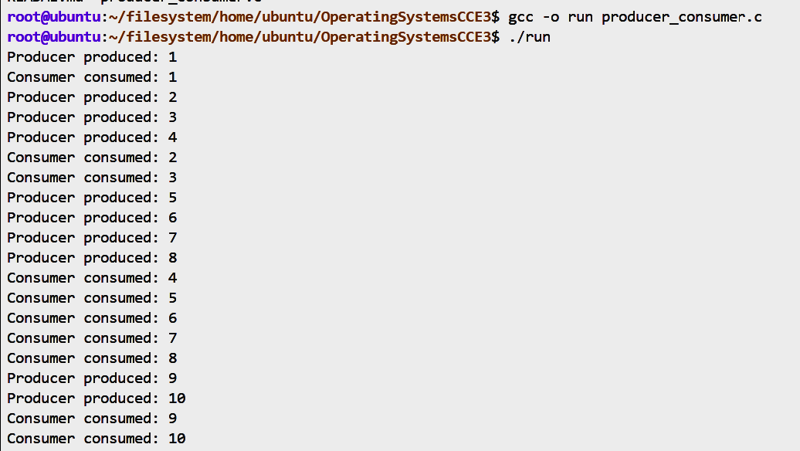
- Producer-Consumer Problem

- Deadlock Detection Algorithm

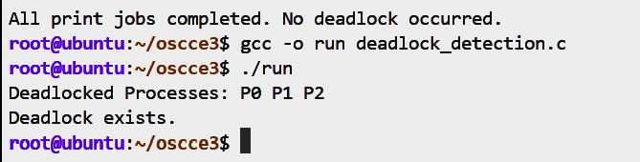

- Synchronization and deadlock
